

College of Science & Engineering

**Course Name:**

**Deep Learning**

Spring 2016

Instructor: Dr. Yin “David” Yang

**By**

**Mohammed Khamis Amro**

Report No1 : Lecture 1 Assignment

## Problem Statement

* Go to <https://playground.tensorflow.org/>
* Choose data 4 (lower right)
* Start training
* Both training error and test error are high
* Training error lower than test error

**Your task**

* Obtain as low test error as possible
  + Given the above, use as few neurons as possible
* Results should be stable
  + Shaky pictures don’t count
* Deliverable
  + A screen shot
  + Your test error
  + Number of neurons used
  + Report

1. Screen Shot

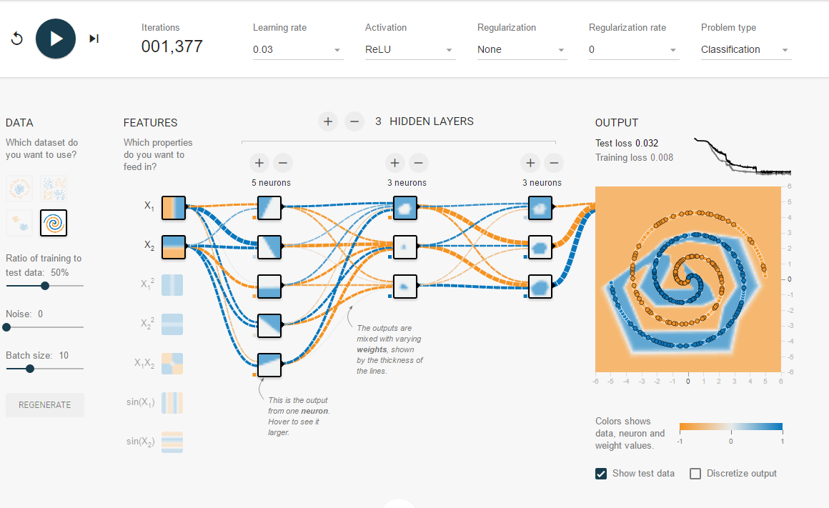

1. Test Error = 0.032
2. Number of neurons used: 3 Hidden Layers with 5 neurons in first layer and 3 neurons in second layer and 3 neurons in third layer
3. Report

Start of the default setting and add one more layer than add one neuron for each layer after 1377 training iteration we got 0.032 testing error rate

In order to determine the lowest number of layer/neuron required I start by remove one neuron form first layer but after 1338 iteration the testing error become 0.304 which indicate that we need at least 5 neurons in first hidden layer



Adding one neuron back to the first hidden layer and remove one neuron form second layer does not enhance the test error rate even after more than 2000 iteration

